ADDENDUM #5

November 27, 2020

TO: Potential Offerors
FROM: Cora Shirai, Contract Manager
RE: Solicitation Addendum #5 to RFP #21-01/IP Telephony System

This correspondence serves as Addendum #5 to the subject Request for Proposals (“RFP”). Your response to this RFP should be governed by the content of the original RFP and the revisions/corrections/additions/clarifications provided in this addendum notice.

The following questions were asked:

[Italic Red comments in brackets are from RFP]
Questions meant for every location unless specifically called out.

- Q: Given existing or new analog stations don’t require data cable. Did you want to reuse the existing cabling for the analog stations or did you want new CAT6 cabling for these too?

A: Use existing cables in patient rooms. Will need new cables for other areas.

- Q: Are there any plans for the credit card machines to process via the Internet instead of analog modems?

A: Yes, working with the bank.

- Q: What are the working hours available for the different areas; i.e. public areas, rooms, offices, facility closets, etc…

A: 8:00am-4:30pm Mondays – Fridays, excluding holidays.

- Q: What are facilities requirements for containment of working in ceiling areas in patient areas?

A: Contain dust.

  - Q: Does the facility provide pop up containment shrouds?

A: No.

- Q: [Overhead paging must also be available.] – Connect to existing paging or provide new?

A: Connect to the existing paging system.

- Q: Are the uplinks between MDF’s and IDF’s at KVMH and SMMH fiber?

A: Yes.

  - Q: If so, are there spare fiber pairs that can be used for the voice network?

A: Not all IDFs have spares.

  - Q: If not all locations have fiber or spare fiber, which locations have spare fiber?
A: May have some at KVMH and SMMH.

  - Q: If unsure, can we identify spare fiber and use it for voice network?

A: Yes.

- Q: Are existing data racks with spare space available for mounting voice/cable equipment?

A: Yes.

- Q: For locations without sufficient space in existing racks, are there any restrictions on new rack installations?

A: If rack/cabinet need to be replaced, we will incorporate the existing switches and panels. We will also need to coordinate with departments that are impacted.

- Q: Can we put in voice PoE switches in the existing data cabinets at SMMH? See circled example below.

A: Yes if there is adequate room.
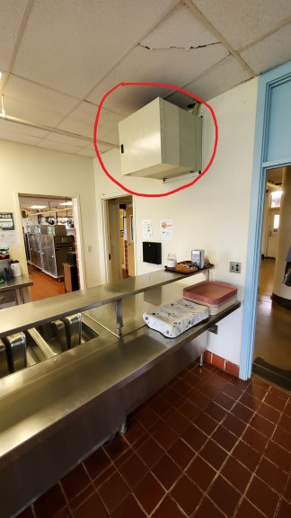
  - Q: Are there spare fiber pairs from these cabinets going back to the MDF that can be used for the voice network?

A: We may have a pair.

  - Q: If unsure, can we survey and use spare pairs if found?

A: Yes.

- WAN Connectivity and High Availability
  - Q: What type of WAN connections will be available for the new system? Please describe the WAN architecture.

A: Undecided at this time.

  - Q: Please describe the potential WAN redundancy.

A: Not known at this time.

  - Q: If no preference or undecided, we can assume and/or suggest best practices.

A: Yes.

- Q: Is the UPS requirement only for the PBX or did you want a UPS for each PoE switch location?

A: Yes.

  - Q: What is the minimum battery backup up-time required?

A: 15 minutes.

  - Q: Should we assume there is an available outlet of correct type at each UPS location?

A: Yes.

- [2.1 Overview - …The proposal should also include installations of new cat5e or cat6 wirings, new phones, new switches, patch panels, and racks and also removal of old phone cables/wirings and phone jacks]
  - Q: Remove cable only where we are running new cable?

A: Yes.

  - Q: Is removal required for abandoned voice cable going back to existing PBX that is not being replaced? For example, an old phone location that is not getting a new IP Phone?

A: Yes.

- [2.3.5 Mobility - The hospitals currently have internal digital mobile phone system as part of the nurse call systems (West-com). It is greatly desired to connect these two systems]
  - Q: Is a point of contact available at West-com to discuss integration?

A: We can contact Westcom and request for a contact.

- [2.2.6 Integration - Ability to integrate alert announcements, i.e. code blue, code red]
Q: Assuming alert announcements is part of same West-com system.

A: Partly. Code blue is a separate system but integrated to the nurse call system.

