RFI ADDENDUM #1

DATE: April 8, 2026

TO: Potential Offerors
FROM: Maia Guirao, Contract Manager
RE: Solicitation RFI Addendum #1 to RFP #26-01/SMMH Emergency Department Renovation

This correspondence serves as RFI Addendum #1 to the subject Request for Proposals (“RFP”). Your response to this RFP should be governed by the content of the original RFP and the revisions/corrections/additions/clarifications provided in this addendum notice.

The following questions were asked:

- Q: In accordance with specification section 01010.1.08.B.1, the owner intends to award the construction contract prior to June 30, 2026 but section 01010.1.09.C identifies that the Notice to Proceed may occur approximately ten (10) months following the bid date. Being that escalation can’t be accurately projected for that time, how does the owner wish to stipulate pricing requirements to maintain an even bidding field? Owner may want to include a stipulated escalation allowance.

A: Understanding a possible delay in the notice to proceed of up to 10 months from the bid date and construction award, owner requests all bidders to explain the price escalation methodology used in the delay scenario. The volatility of the current material supply chain is acknowledged. Furthermore, owner is committed to fund unexpected material price escalations through an invoice validation process.

- Q: Will construction for this project occur concurrently with the SMMH New Psychiatric Unit project?

A: Yes.

- Q: In the table of contents, Appendix F refers to pages 5 to 8 of Exhibit A, but the Exhibit A included appears to be a single page.

A: Exhibit A is the project specifications. Appendix F (Bid Form) is included.
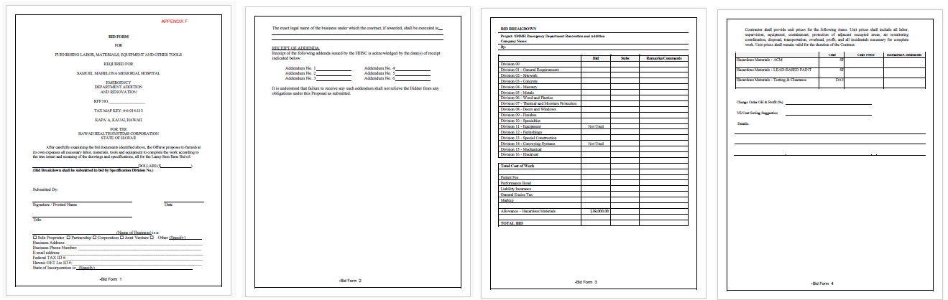

- Q: Please verify if any signage or graphics are part of this contract.
A: No graphics/signage will not be part of this contract.

- Q: Should the effluent off the Decon Shower be captured for assessment or treatment prior to the discharge into municipal sanitary system?

A: A Decontamination is added to store discharge from Decon Shower, see updated P-101, P-103.

- Q: Of those items identified as CFCI on the Equipment Schedule, there is a specification section for the headwalls but we are missing the specifications for the other highlighter items. The legend for the Equipment Schedule identifies OFOI and OFCI, by chance are some of these CFCI items such as the Philips Healthcare items labeled incorrectly? Note that there are discrepancies between identification of responsibility between the equipment schedule and the interior elevation, detail section drawings.
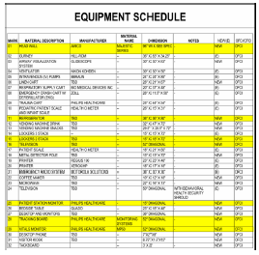

A: Yes, some items misidentified. Revised equipment schedule is attached.

- Q: Please expand on the scope for the OFCI items on the Equipment Schedule. Not all equipment identified appears to require actual installation. Please provide cutsheets for those that require actual mounting or assembly.

A: Equipment schedule revised to show OFOI as an option. Cut sheet attached for items requiring mounting. (See file: “Reference for RFI Addendum #1 Question #7”)

- Q: Will all new equipment be delivered to a single point for distribution by the contractor? Will all existing equipment be stored in one location for the contractor to distribute? We are unable to identify salvage requirements, if any, for the existing equipment. Please confirm if necessary as well as any requirement to relocate to storage.

A: HHSC to remove all salvaged equipment prior to contractor starting work. HHSC to provide storage for equipment.

- Q: For those OFCI computer equipment, please clarify the extent of installation.

A: Computer equipment will be OFOI, GC to provide power and data outlets.

- Q: Specification section 10416 Directories and Bulletin Boards although listed on the TOC appears to be missing from the specifications downloaded.

A: Section added.

- Q: Should the crash cart in Trauma-2 be on a dedicated circuit? Circuit E-34 appears to be shared.

A: See E-112, Crash cart in Trauma-2 room power updated to dedicate circuit. Also, Microwave and Ice Maker in Nourish room had updated to dedicate circuits as well.

- Q: Please provide GB designation in PT SHWR/DECON.
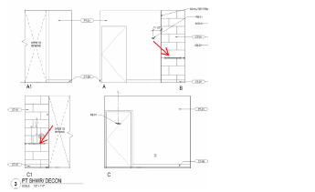

A: 24”B-5806x24 bobrick grab bar will be added to schedule. See SMMH ED_Addendum 1 on the website.

- Q: Please identify specification of RB-01 in PAT TLT.
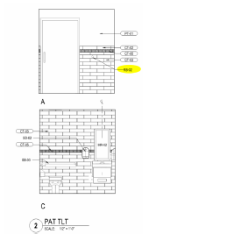

A: Specification for RB-02 will be added to schedule see SMMH ED_Addendum 1 on the website.

- Q: Please confirm specification of BSC-01 in ADA TLT.
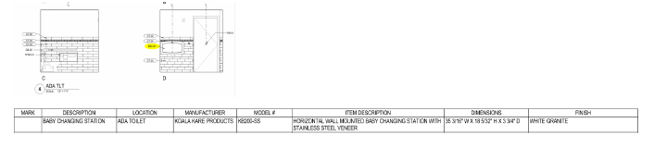
A: BSC is a typo should be BCS-01 is a Baby changing station under the description on the schedule type mark is missing from the schedule. See SMMH ED_Addendum 1 on the website.

- Q: Should the locker base in the STAFF TLT be concrete to avoid water damage or rust with floor contact?
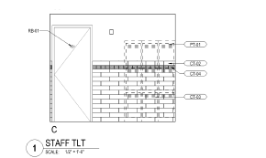

A: Locker elevation corrected, base not needed, the existing lockers are on legs to avoid water damage and rust.

- Q: Please identify any monitoring or services providers for the existing facility. Example – Fire Alarm, DDC, etc.

A: Fire Alarm – Island Signal & Sound
DDC – American Controls
AV – In-house
Security – TBD by Owner
Cable – Hawaiian Telcom

- Q: There is a bath accessory schedule on sheet A-621 and a toilet accessory schedule on sheet A-622, that appears to be identical. Please clarify the intent of the 2 schedules.

A: Inclusion of A-622 in the set is a mistake. Bath Accessory Schedule on A-621 to be used.

- Q: Detail 7/L-204 identifies work “by others”. Please confirm that there is no separate bid for this work but it is work as part of this bid identified by other design disciplines.

A: Confirmed, work part of bid but done by other design disciplines. (See file: “Reference for RFI Addendum #1 Question #18”)

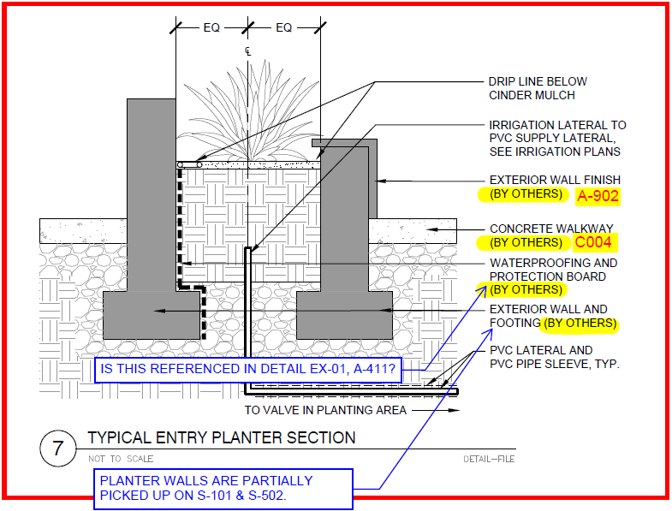

- Q: Specification section 01450 – Quality Control identifies Owner’s Responsibilities: Pay for testing and inspections by an independent Testing/Inspection Service for tests and inspections required by Special Inspections, but specification section 07811 – Spray Applied Fireproofing identifies special inspection by contractor. Please confirm that section 01450 shall govern.

A: 01450 gives guidance unless noted otherwise. Owner pays for special testing and inspections, Contractor Engages and Schedules.

- Q: Phase A disconnects medical gas system from remaining active patient care areas. Please identify if the lower level / crawl space med gas work shall occur prior to phase A or if the owner will provide portable systems for those active patient care areas during phase A.

A: Contractor review note 1 on sheet PD-104. Contractor must provide new medical gas piping as shown on P-105 prior to demo work on PD-104.

- Q: Please advise of permit status, anticipated start and completion dates.

A: Building permit application will be submitted in April 2026. Please note the permit submittal cannot be reviewed by the building department until the EIS is complete and approved.

- Q: Sheet C002, the erosion control plan does not show dust fence or limits, please confirm if required provide limits.

A: No using a dust fence.

- Q: Sheet A-401, detail 1 shows an Exterior Metal Sign but there are no signage schedule or specs, please confirm if required and provide specs/details.

A: Exterior metal sign is provided by the owner. Sign was fabricated for a previous project and is on-site already.

- Q: The Color and Material Finish Schedule on Sheet A-621 lists CT-06 as Keystone 2”x2” Urban Putty D161, Moonshine D117, and Urban Putty Speckle D201.
Could you confirm that this will be a custom mosaic random mix and the mix percentages of each tile color?

A: Equal blend of all 3.

- Q: The Enlarged Finish Floor Plan on Sheet A-623 shows CT-01 (12x24) for the floor finish for 102 ADA TLT, 105 PT Shower/Decon, 108 PAT TLT, and 110 Staff TLT. The Enlarged Finish Floor Plan on Sheet A-623 also shows CT-06 (2x2 mosaic) specifically for the shower floor finish in room 105 PT Shower/Decon.

The Room Finish Schedule on Sheet A-621 lists CT-06 as the floor finish for 102 ADA TLT, 105 PT Shower/Decon, 108 PAT TLT, and 110 Staff TLT. The Room Finish Schedule on Sheet A-621 also shows CT-06 for 105 PT Shower/Decon.
Please confirm we should follow the Enlarged Finish Floor Plan on Sheet A-623, with CT-01 being the main floor tile and CT-06 only used specifically for the shower floor tile.

A: Correct CT-01 is the flooring for all bathrooms. CT-06 is only used in the shower.

- Q: The Color and Material Finish Schedule on Sheet A-621 states that CT-08 is Daltile’s Society 4”x12” cove base. The cove base trim for that tile line only comes in 6”x12”.
Is it acceptable to use the 6”x12” cove base for CT-08?

A: Yes 6”x12” cove base to be used. 4” is a typo.

- Q: Drawing 3 on Elevation B on Sheet A-502 shows a Schluter trim. The exact Schluter trim is not called out on the drawings or in spec section 09310.
Would a Schluter-JOLLY satin anodized aluminum trim be acceptable?

A: Yes Schluter-Jolly satin anodized trim is acceptable.

- Q: For rooms 102 ADA TLT, 108 PAT TLT, and 110 Staff TLT, the field wall tile (CT-03) is Color Wheel Linear 4x16 in Arctic White 0190. For the cove base in these rooms, Color Wheel Linear cove base is only available in 4x12. Please confirm this will be acceptable.

A: Wall tile to go to the floor. Schulter Dilex-HKS cove base in satin Adonized aluminum finish to be used at floor/wall transition.

- Q: Please advise if the project shall allow non-union contractors to participate at prevailing wage rates.

A: Yes, the project shall allow non-union contractors to participate at prevailing wage rates.

- Q: Please provide the status of the building permit. If issued by the County, please identify the building permit number.

A: Building permit application will be submitted in April 2026. Please note the permit submittal cannot be reviewed by the building department until the EIS is complete and approved.

- Q: Please provide the status of the demolition permit. If issued by the County, please identify the building permit number.

A: Building permit application will be submitted in April 2026. Please note the permit submittal cannot be reviewed by the building department until the EIS is complete and approved.

- Q: Please provide the status of the NPDES permit. Please confirm that all responsibility shall remain with the owner.

A: No NPDES permit needed for this project.

- Q: Section 01040 – Coordination identifies under section 1.03 Quality Assurance, Key Personnel at a minimum shall be 1) a full-time superintendent, 2) a full-time QC Officer, 3) a scheduling engineer, 4) two (2) detailers, and the QC Officer being the only personnel of singular responsibility. Please clarify the required minimum personnel as we would not typically staff detailers for a project of this size.

A: Two (2) part time detailers is acceptable.

- Q: During Stage A of construction, external access to the existing waiting area will be cut off. Confirm that the owner will make provisions for alternative access for the public to the existing waiting area.

A: HHSC ED Staff will utilize the new critical access hallway. Critical access project planned to be completed before the ED Renovation project starts.

- Q: During Stage B of construction, the limits of Stage B flooring suggest a barricade that will isolate the existing nurse station with the rooms completed in Stage A except for BH Secure Rm 114. Note that the existing sink wall at the Nurse Station also blocks access, if the limits of Stage B flooring are not adjusted. With the amount of utility work and ceiling work above the nurse station, an interim / temp nurse station may be more feasible. Please review and advise.

A: HHSC ED Staff will set up a temporary nursing station.
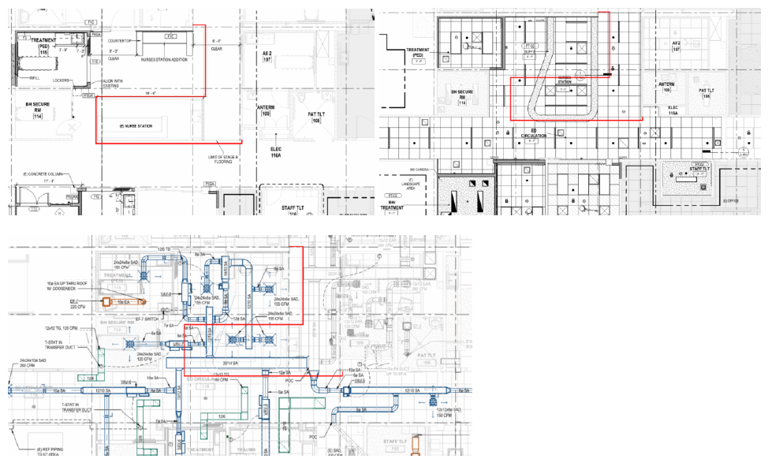

- Q: Sheet A-801 provides window types along with notes which appear to correspond to a window schedule, but is missing a window schedule. Without the schedule, it not clear which windows are security type windows.

A: No security windows required for this project.

- Q: On sheet A-111, PARS [103] illustrates two (2) type 02 windows, but they appear to be a one (1) type 02 and one (1) type 02R. Please confirm.

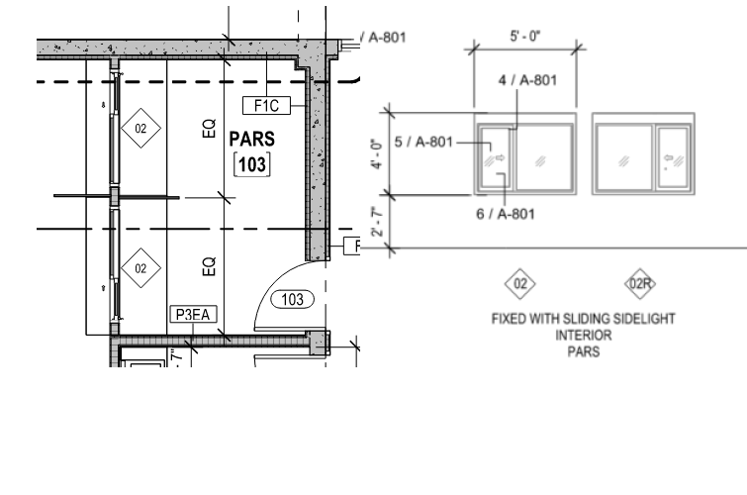

A: Confirmed, one (1) 02 type window and one (1) type 02R window.

- Q: Vitals Monitors – Line 29 – listed as 52”, but likely it is reversed with line 25
- Will trauma have the same size monitor as other rooms? Or would they want larger?
- How many waves does each monitor need to show? (ECG, Resp, SPO2, CO2, invasive lines) Options are 4, 6, and 8
- What brand pulse ox cables do they use and what connection are there? (Masimo, Philips, or Nellcor and RD set or LNCS)
- MP50’s are no longer sold, so these will not be able to be quoted (just an FYI)
- Do we need to include any capnography monitoring?
- Will the head walls include wall channels? Will construction or biomed be responsible for installing the arm to the head wall?
- These will require cables to be pulled to each bed. Who will be responsible for the cable pulls? If us, I will include it in the quote.

A: Vitals monitor is corrected to be an Owner Furnished, Owner Installed item. It will be installed on the headwall, please include data and power outlets on the headwall product.

- Q: Patient Station Monitor – line, likely line 29
Do they want a monitor on the nurses station desk to be interacted with? Typically it’s a 27” display. Another option is to have it be wall mounted, but we need to know if it will be interacted with and require a keyboard and mouse.

A: Patient Station Monitor is corrected to be an Owner Furnished, Owner Installed item.

- Q: Tracking Board
The largest screen we have available to us right now is 43” (our catalog does change, so larger may be available at a later date)- will that suffice? Another option would be relocating the existing display or purchasing a display from another vendor and we can supply the cable to connect our central station to the display (display port or HDMI).

A: Tracking board is corrected to be an Owner Furnished, Owner Installed item.

- Q: Just an FYI-all of our bedside monitors AND our patient station monitor require e-power, please confirm e-power will be provided?

A: Yes, since the entire facility is on the generator, the bedside monitors and patient stations monitors should have e-power.

- Q: Please provide dimensions/sizes for the ramp guardrail and railing components.

A: Dimensions and view reference added.

- Q: Sheet AD-103 Overall Demo RCP is missing from this set, please provide.

A: Sheet added.

- Q: Is there soils Report available?

A: No Geotech report was done for this site. See attached for a similar report done for the BH site. (see file: “Reference for RFI Addendum #1 Question #51”)

- Q: L-200 Landscape Irrigation plan references Electrical drawings for power designation related to irrigation controller, however no designation is provided on Electrical Sheets. Further, there does not appear to be a circuit designated for landscaping power on Panel Schedules.

A: Irrigation controller power is added to E-101 & E-701.

- Q: Confirm if power is required for rain sensor shown next to Irrigation Controller on Sheet L-200.

A: No separate power source is required. The rain sensor shall be connected to the irrigation controller, which will supply power to the sensor once installed.

- Q: Please indicate the amount of time that the owner will need between phases from turnover to start of demo on the next phase.

A: Once new rooms are complete, HHSC ED staff will need 2 days to move items from the current room into the new room.

- Q: Specification section 02300 – Earthwork identifies a Soils Report that is available from the owner. I could not locate it with the bid documents. Please provide.

A: No Geotech report was done for this site. See attached for a similar report done for the BH site.

- Q: Specification section 02900 – Planting stipulates “Allowances for plants are specified in Division 01. Section 01210 – Allowances only identify the Hazardous Materials allowance. Please clarify.

A: Section to be deleted.

- Q: Specification section 02900 also notes acceptable sources for native plants to a one nursery on Oahu. Please confirm that is intended.

A: Section to be deleted.

- Q: Is there soils Report available?

A: No Geotech report was done for this site. See attached for a similar report done for the BH site. (See file: “Reference for RFI Addendum #1 Question #51”)

- Q: Section 7421 Direct Applied Exterior Finish System calls for a performance warranty of 5 years.

A: Contractor and Surety will only be held liable for two years after substantial completion date.

- Q: Section 8520 Glazed Aluminum Systems, para. 1.08, B., calls for a workmanship warranty for 5 years.

A: Contractor and Surety will only be held liable for two years after substantial completion date.

- Q: Section 9545 Suspended Wood Ceiling, para. 1.08, C., 2, 10 years by manufacturer and Contractor.

A: Contractor and Surety will only be held liable for two years after substantial completion date.

- Q: Section 9905 High Performance Coatings, repair of replacement warranty 10 years.

Our Surety will not accept anything over 2 years (manufacturers warranties over 2 years are okay but not if includes performance/labor).

A: Contractor and Surety will only be held liable for two years after substantial completion date.

- Q: Section 5140 Aluminum Equipment Screens, please confirm if Section 10240 Sound Barrier Wall in Addendum 1 replaces this Section? If not, where does this section pertain to?

A: Mechanical enclosure screen revised to louver type. See section 10250,
SKA-03 & 04 for revised enclosure. (see file: “Reference for RFI Addendum #1, Question #56”)

- Q: Specification Section 02900, paragraph 1.07-C-1-d states: “The Architect reserves the right to have plant samples analyzed at any time to verify plant health and conformity to Specifications. Furnish samples upon request. Testing to be done by the Architect’s designated laboratory.” Since the cost of testing is the responsibility of the contractor, please provide more information about when the Architect intends to use this clause – what would the plants be tested for? If there was a question about a plant’s health, it seems more cost effective if the Architect would simply reject the material rather than go through the process of expensive laboratory testing. Please clarify the intent of this specification so that the bidding contractors can account for it in their bids.

A: The intent of the specification is intended to assist in determining the species of the installed plant should there be a discrepancy with the contract drawings. Some plant varieties do not exhibit particular growth or color variation until maturity.

- Q: Can Hibiscus waimeae be substituted with Hibiscus arnottianus?

A: Yes, Hibiscus waimeae can be substituted with Hibiscus arnottianus.

- Q: On sheet L300, there’s an area at the SE corner of the parking lot (between the parking lot and the building) that appears to be gravel, but there is no callout and it is not shown in the material schedule on sheet L303. Please confirm if this is to be gravel – and if so, please provide gravel size, depth, and confirm if it is to be installed over filter fabric.

A: Yes, a 137 sq. ft., 2" layer of gravel should be installed with filter fabric below.

- Q: Can the DeepRoot root barrier be substituted with BioBarrier?

A: Please provide DeepRoot barrier.

- Q: Specification for backfill mix for trees, shrubs, groundcovers and palms references using “Menehune Magic”/organic composted soil amendment. Can the contractor simply use “organic composted soil amendment” or is “Menehune Magic” specifically required?

A: A substitution request may be submitted for consideration after project award is given.

- Q: Can ½” Rainbird swing tubing be used in place of the Sch 80 swing pipe to connect the irrigation heads to the lateral line?

A: A substitution request may be submitted for consideration after project
award is given.

- Q: Can the type K Copper be substituted with DR11 HDPE pipe? Since the HDPE pipe is in a continuous roll (rather than 10’ or 20’ lengths), there would be no joints/connections under the pavement in the areas where the copper pipe is shown, so less chance of any weak points to fail under the pavement areas.

A: HDPE PE4710 DR11 pipe may be substituted for Copper Type K Hard. Please provide butt fusion welded connections and fittings. Socket fused connections and fittings will not be accepted.

- Q: Can the specified Rainbird XFS-09-12 tubing be substituted with Netafim CV17mm TLC9- 12 drip tubing?

A: Please provide Rain Bird XFS-09-12 drip tubing.

- Q: Can the specified VIT Stong Box SB-24SS be substituted with Rainbird LXMMSPED Stainless Steel Pedestal (made for Rainbird ESP-LX Series controllers)?

A: Please provide the specified VIT Strong Box SB-24SS stainless steel enclosure.

- Q: On sheet L305, detail 1 shows the rain sensor mounted to the side of the controller enclosure. Detail 2 shows the rain sensor mounted on a separate post. For ease of
maintenance, we would recommend / prefer the rain sensor to be mounted on the controller pedestal. Please confirm rain sensor mounting method for bid purposes.

A: Mounting rain sensor to the side of the irrigation controller enclosure is acceptable provided sensor has full exposure to rainfall.

- Q: ST-01 is identified for planters, but the elevation drawing appear to take it past the planter. Please confirm the termination points.
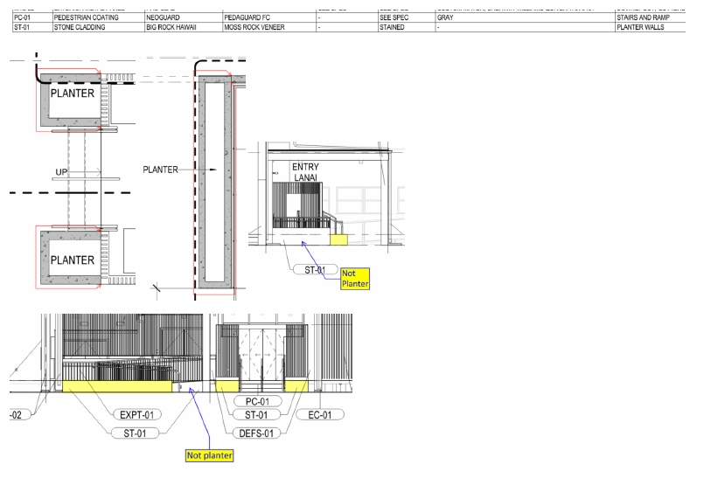

A: Confirmed, ST-01 should wrap planters and ramp walls. Mark ups shown are acceptable.

- Q: Specification Section 01450 identifies special inspection by owner. Section 05120, 05310 and section 07811 appear to contradict section 01450 and places special inspection onto the contractor. Please clarify.

A: Special inspector(s) must be retained and paid for by the owner as stipulated in 01450 QUALITY CONTROL. Contractor is responsible for field and laboratory testing, such as slump testing, making and testing of concrete strength test cylinders, etc.

- Q: The Amerock 5-1/16” Rift cabinet door pull shown base cabinet details advertised as ADA compliant, but the Hafele Showcase 111.04.114 shown on the upper cabinet and drawer details are not specifically advertised as ADA compliant. Please confirm.

A: Use Amerock 5-1/16" Rift cabinet pulls on upper cabinets and drawers.

- Q: Please identify where detail 2/A-903 shall apply. We are unable identify an elevation where both the aluminum slats and moss rock veneer are assembled as detailed.

A: 2/A-903 is at the wall between the ambulance drop off and the accessible ramp at the main entrance.

- Q: Under specification section 08710, lockset manufacturers listed all appear to fall under the ASSA ABLOY umbrella of brands. Being that a portion of the facility is on the Primus keying system, please confirm manufacturers under the Allegion umbrella of brands are acceptable as well. This should provide a more competitive bidding field.

A: Allegion is acceptable.

- Q: Note that Kingsway and Electric Mirror do not provide the 15 year warranty identified in specification section 10800. Will an exception be made?

A: Kingsway standard warranty is acceptable.

- Q: Please confirm that no chemical termite treatment is necessary for this project.

A: Ground treatment before construction is needed.

- Q: Fire suppression drawings are included in drawing set, but no specifications are provided. Please provide or confirm Fire Sprinkler notes on P-001 shall serve as specs.

A: Section 13930 - Fire Sprinkler System attached. (See file: “Reference for RFI Addendum #1, Question #74”)

- Q: Per Mechanical Equipment Schedule E-802, EF-1/2/3/4/7 to be fed by circuit E-3. E-701 Panel Schedule notes Lighting Room 101-109 designated for this circuit. Provide alternate circuit. Confirming all lighting within the building in Stage A shall be fed by E-3 and all lighting within the building in Stage B shall be fed by D-1.

A: See updated panel schedule E. Exhaust fan in Toilet room will connect to light switch E-3 (no alternate circuit). Yes, all lighting within the building in Stage A shall be fed by E-3 and all lighting within the building in Stage B shall be fed by E-1 (not D-1). (See file: “Reference for RFI Addendum #1, Question #75”)

- Q: Technical Specifications Table of Contents Page 3 indicates Specification Section 10416 – Directories and Bulletin Boards. However, no specifications are provided in the specs. Provide specifications if this is to be CFCI.

A: 10416 should have been included in Addendum. See SMMH ED_Addendum 1 on the website.

- Q: Specification Section 10520 is provided for Fire Extinguishers and Cabinets, however these could not be located on Life Safety or Architectural drawings. Provide locations and details.

A: See sheet SKA-01 for FEC locations. (See file: “Reference for RFI Addendum #1, Question #77”)

- Q: Addendum 1 provides a new sheet in A-907 that provides details for new sound barrier wall. Detail 1/A-907 shows a concrete footing with reference to structural, however, nothing was provided in Add 1 related to structural design for these posts. Confirm dimensions of footings and if new posts will need to be cast-in-place or may be post-installed.

A: Posts can be cast into the drilled shaft footing, or installed separately from the footing. If the post is installed after the footing is in place, the size of the footing may have to be larger to accommodate a base plate and anchor bolts. Everything above the foundation is a delegated designed system. Therefore, the exact sizes and dimensions of the posts for the system is unknown. The bid must be based on the detail on the next sheet. Final design of the foundation will depend on the shop drawings for the barrier system. Footing shown is based on a 100 ft2 effective wind area per footing. Also see SKA-03 and 04 for revised mechanical enclosure. (See file: “Reference for RFI Addendum #1, Question #78”)

- Q: C001 Site & Grading plan does not designate a finish for the new parking lot. Legend notes grey shading for Asphalt Concrete designation but is not represented on plans. Confirm parking lot is new AC paving throughout.

A: Parking lot is AC.

- Q: C004 Site Details provides a typical detail for transition of new AC paving to concrete pavement, however, there does not appear to be any conditions where AC transitions into concrete, as shown. Please confirm.

A: (See file: “Reference for RFI Addendum #1, Question #80”)

- Q: Overall Demo Plan AD-101 calls for asphalt paving to be removed fronting ER facility assuming that continual access for ambulances to existing entry is not required. Confirm alternate means of ingress & egress will be utilized.

A: ED shall be accessed through the CAH hallway during Stage A construction. Contractor to provide continuous access from ambulance drop off to ED entry.

- Q: Enlarged Demo Stage A Plan, AD-104 shows call-out D7 for exterior finish removal along GL B. While extent of new Exterior Finish is shown on AD-101 at GL F, the extent of new exterior finish is now represented on GL B. Confirm new exterior finish shall terminate at GL B/4.

A: New exterior finish shall extend to the new CAH hallway. See sketch SKA-02. (See file: “Reference for RFI Addendum #1, Question #82”)

- Q: Existing antenna apparatus, and all associated wiring, at exterior wall to roof (near GL B/3) is not represented on drawings. Confirm this shall be disconnected or if shall remain with temporary supports for duration of construction. With existing high roof to be removed, confirm re-mounting details and locations. Confirm new exterior finish shall be patched around existing utilities along GL B façade.

A: Antenna shall remain with temporary supports throughout construction. Re-mount to lower roof. Confirmed new exterior finish shall be patched.

- Q: Specification section 08330 refers to electric operators, but electrical drawings do not appear to indicate power for the roll up door. Please clarify.

A: Antenna shall remain with temporary supports throughout construction. Re-mount to lower roof. Confirmed new exterior finish shall be patched.

- Q: Sheet E-111 appears to be missing power designation for the ACCU-1 and ACCU-2, although SMMH ED panel schedule identifies the circuits. To avoid the reasonably inferred argument, please add to E-111.

A: ACCU-1 and ACCU-2 power connections had added to power plan.

- Q: Wall types identify impact resistant gypboard but specification section 09250 does not appear to address the basis of design.

A: Impact resistant gypsum board added to 09250. (See file: “Reference for RFI Addendum #1, Question #86”)

- Q: Behavioral Health rooms are identified with RB-01. Was there any concerns from staff of removal by BH patients? Specification section 09651.3.04.C identifies integral where occurs but as noted it is not identified. Please clarify.

A: BH Secure room should have an integral cove base.

- Q: Specification Section 07130 makes reference to waterproofing system at retaining walls, planters and foundations, however, there are no waterproofing details provided on Architectural drawings. Only Detail 7/L-204 shows a vague image of waterproofing at only one side of planter walls. Confirm all locations where waterproofing shall be applied and provide all required transition details.

A: Waterproofing is not within landscape scope of work. Defer to architect for answer to question. Provide waterproofing inside planter, see SKA-05 for waterproofing at planter detail. (See file: “Reference for RFI Addendum #1, Question #88”)

