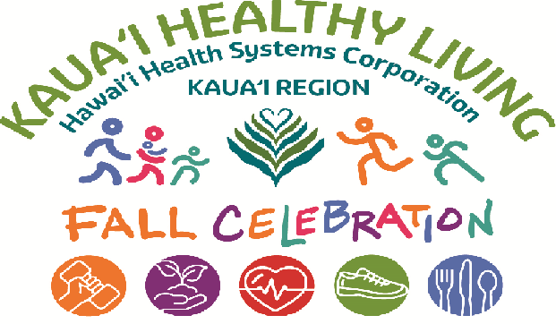

COME, JOIN US!! Ask questions, learn and have fun!

Saturday, September 19, 2026
9:00 am to 12:00 pm
KVMH Annex 1 (lower parking lot)

Featuring delicious eats and treats from these foodies:
- HHSC Kauai Region Nutrition Department – assorted menu choices
- Kauai Menehune Kitchen – delicious baked goods
- Keiara’s Lemonade and Sweet Treats – assorted chilled drinks
- Little Luna – assorted frozen treats)

Informative Community Resources from these organizations:
- Ho’ola Lahui Hawaii, Kauai Community Health Center
  - Primary Care and Dental Services
- County of Kauai, Office of Elderly Affairs – information about staying healthy as an older adult
- County of Kauai, Congregate Meals
- State, Kauai District Health Office
- Hawaii Food Bank, Kauai – Mobile Pantry
- Alzheimer’s Association of Kauai – various information available regarding caregiver support groups, types of dementia.
- Diagnostic Laboratory Services
- Kauai Fire Department – learn more about how to stay safe in a situation involving fire, education for Keiki – stop, drop, roll
- Ohana Pacific Health
- SANE Representative (Sexual Assault Nurse Educator)
- Kauai BIG (Brain Injury Group)
- Child and Family Services – Head Start

Services available in the Kauai Region at KVMH, SMMH and its Urgent Care and Clinics
- Emergency Department
- Surgery (only at KVMH)
- Medical/Surgical
- Intensive Care Unit/Critical Care Unit (only at KVMH)
- Obstetrics / Labor and Delivery (only at KVMH)
- Long Term Care
- Behavioral Health (only at SMMH)
- Pharmacy (inpatient)
- Kawaiola Pharmacy (retail) (only at KVMH)
- Nutrition
- Education / Centering
- Rehabilitation –Physical, Occupational and Speech Therapy
- Respiratory Therapy
- Social Services
- Kauai Region Clinics and Urgent Care and Providers
  - The Urgent Care at Poipu
  - The Clinic at Waimea
  - The Clinic at Port Allen
  - The Clinic at Kalaheo (temporarily closed for renovations)
  - The Specialty Clinic at Kalaheo
  - The Clinic at Lihue
  - The Clinic at Kapaa
- Finance
- Human Resources

